# Forget password doesn’t exist

User should be able to change password using forget password functionality

|  |  |  |  |
| --- | --- | --- | --- |
| Severity | Issue type | Frequency | Environment |
| Medium | functional | Every time | All browsers |

## Action Performed

Open the http://cmdlhrvm54/portal/login

Try to login and if don’t remember password, look for forget password.

## Expected Result

User should be able to recover password using forget password functionality

## Actual Result

Forget password not available

## Attachments

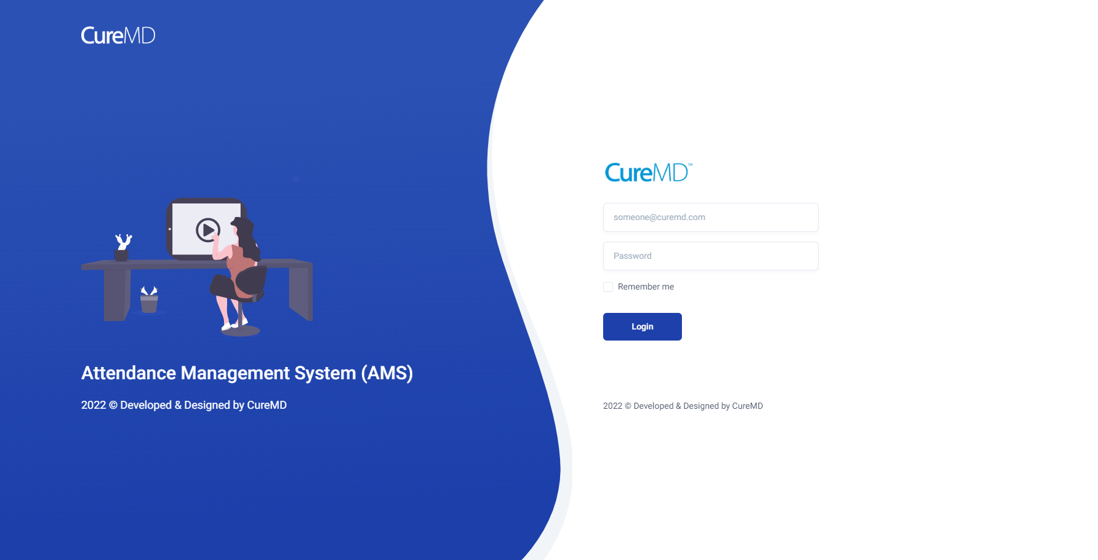

# User can input any Data types in input fields

User should be able to only enter data fields for which they are made.

|  |  |  |  |
| --- | --- | --- | --- |
| Severity | Issue type | Frequency | Environment |
| Low | functional | Every time | All browsers |

## Action Performed

Open the http://cmdlhrvm54/portal/login

Login

Click user name on upper right corner then select profile

Click personal info.

## Expected Result

User should be able to only enter data fields for which they are made.

In name field only String should be allowed.

In phone number only numbers should be allowed.

In blood group there should be drop down menu to select blood group.

## Actual Result

User can enter any data type.

## Attachments

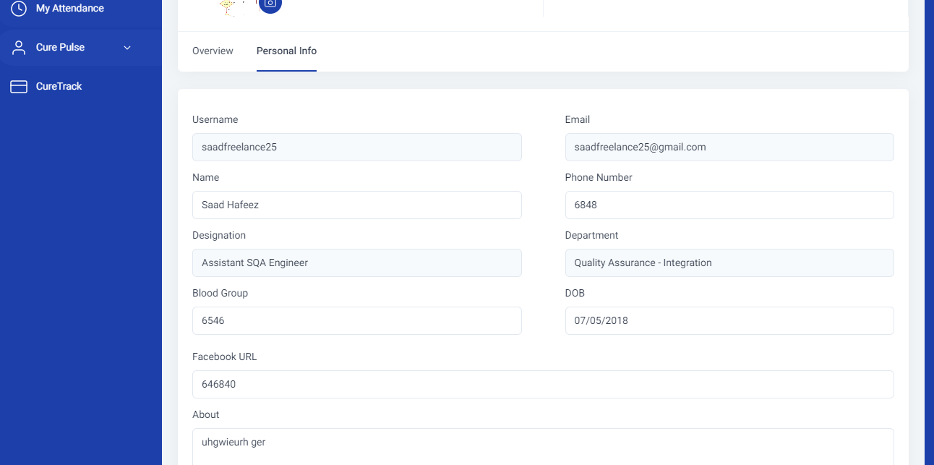

# Some functionalities are not available on small screen

User should be able to apply leave and book appointment from phone

|  |  |  |  |
| --- | --- | --- | --- |
| Severity | Issue type | Frequency | Environment |
| Medium | functional | Every time | All browsers |

## Action Performed

Use smart phone

Or rescale browser window to match mobile screen

Open the http://cmdlhrvm54/portal/login

Login

Try to apply leave or book appointment.

## Expected Result

Apply leave and book appointment should be available on all screen sizes.

## Actual Result

Apply leave and book appointment functionality is not being displayed.

## Attachments

